Microsoft Teams Rooms

Microsoft Teams Rooms (formerly Skype Room Systems version 2) brings HD video, audio, and content sharing to Teams or Skype for Business calls and meetings of all sizes, from small huddle areas to large conference rooms.

## **What do you want to do?**

## **[Learn about the touchscreen console](javascript:)**

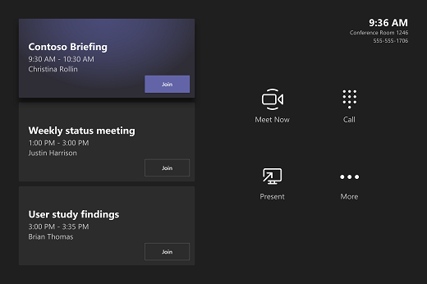

The touchscreen console in a conference room is the heart of every meeting. It automatically wakes up when it detects motion. On the screen, there are a few things you can do:

* Join a scheduled meeting by selecting the meeting.

**Note:** To get a meeting to show up on the room console, organizers should set the room as the meeting location.

* Start a new meeting by selecting **Meet now** Meet now button .
* Make a phone call by selecting **Dial pad** Dial pad button and dialing a number.
* Project your laptop by plugging in the cable connected to the console. Depending on the room settings, it may be projected to the room automatically, or you may have to select **Present** Share desktop button on the room console.
* Select **More** More options button  for instructions on how to add the room to a meeting, give feedback on the device, or change settings.

When you're in a meeting, you'll have options to manage your camera and mic, share content, add participants, and end the call.  
  
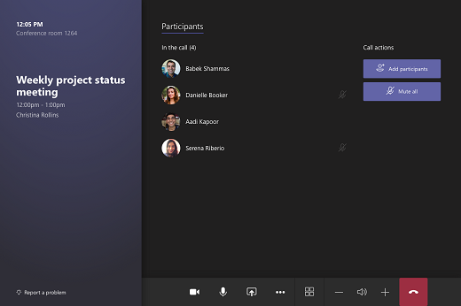

In Skype for Business meetings, you'll also have the option to check out conversations and content.

## **[Invite a room to a meeting](javascript:)**

**Use Outlook to reserve a room equipped with Microsoft Teams Rooms**

1. Open Outlook, and go to your calendar.
2. Select **New Teams Meeting** in the **Teams Meeting** section or **New Meeting**, then **Teams Meeting**.
3. Select **Room Finder**in the meeting scheduler or type the conference room email address.
4. Select **Show a room list** and find a building or list.
5. Choose a room from the list of available rooms.
6. Complete the meeting invitation as you would for any other meeting before sending.

**Use Skype for Business to add a Microsoft Teams Rooms room to an existing meeting**

1. Join the meeting from your personal device.
2. Select **Invite More People**.
3. Search for the room name (it's on the console), and select **OK**.
4. Accept the call on the console to join the meeting.

**Use Outlook to add a Microsoft Teams Rooms room to an existing meeting**

1. Open the meeting in Outlook on your personal device.
2. Add the room name (it's on the console) under **To**or find the room using **Room finder** in the meeting scheduler, and send the update.
3. If the meeting is accepted, it will appear on the console.
4. Select the meeting on the console to join.

## **[Join a meeting](javascript:)**

**Join a scheduled meeting**

Just find your meeting on the console and select it to join.



Any meetings currently happening are at the top of the list. After a meeting ends, it'll stay on the screen for a little while so you can easily join again if you need to.

If a scheduled meeting doesn't appear on the console (or if the meeting tile shows **More options ...** instead of **Join**), you will need to [invite the room](https://support.microsoft.com/en-gb/office/microsoft-teams-rooms-help-e667f40e-5aab-40c1-bd68-611fe0002ba2?ui=en-us&rs=en-gb&ad=gb#bkmk-schedule-meeting) or add the room on your personal device.

**Join a scheduled meeting that's not on the console**

1. Join the meeting on your personal device.
2. When you're choosing your audio and video settings you have the option to add a room so you can use that room's audio and video equipment. Your personal device may even detect a nearby room using Bluetooth.  
     
   If it does, you'll see the meeting room's name and the option to **Join and add this room**. If the nearby room has already joined the meeting, just select **Audio off** to join with your audio off and avoid disrupting the meeting.  
   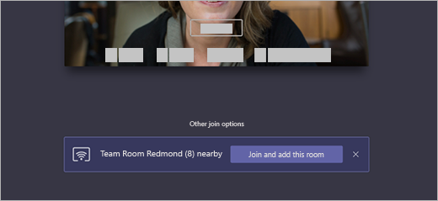
3. If your device doesn't detect the room nearby, select **Add a room** under **Other join options** and search for the room you're using.  
   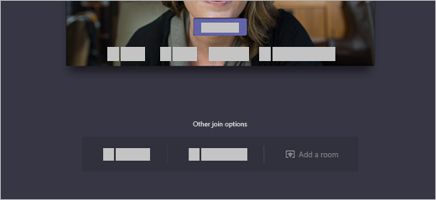
4. If you've already joined the meeting on your personal device, you can select **Show participants** Add people to team button , then go to **Invite someone or dial a number** and search for the room name. Then, select the room and **OK** to call it into the meeting.
5. Then, the room will ring. To join the meeting, select **Accept** on the room console.

**Note:** Make sure the audio on your personal device is off before you accept the call on the room console, or you could cause echo.

## **[Start an unscheduled meeting](javascript:)**

1. Select **Meet now** Meet now button on the room console.  
   
2. Under **Type a name or number**, find the people you want to invite.
3. Select people to add them to the list of invitees.
4. After all the people you want to invite are on the list, select **Invite**. Your meeting will begin automatically.
5. Or, if you have a URI for a meeting you want to join, select **Enter a URI** and type the URI for the meeting.

**Note:** For now, this is only available on Skype for Business.

## **[Share content](javascript:)**

**Share your screen with in-room participants**

To share your desktop with in-room meeting participants, just connect your personal device to the appropriate cable connected to the room console.

Depending on your room settings, your screen may be shared automatically, or you may have to select **Present** Share desktop button on the room console.

**Share your screen with all meeting participants**

There are two ways to share with both in-room and online participants from a personal device:

1. Join the meeting on your personal device and select **Share** Share screen button , then the item you want to share. Go to [Share your screen in a Teams meeting](https://support.microsoft.com/en-us/office/share-content-in-a-meeting-in-teams-fcc2bf59-aecd-4481-8f99-ce55dd836ce8) to learn more.
2. Connect your personal device to the cable connected to the room console. Depending on your room settings, your screen may be shared automatically or you may have to select **Share** Share screen button on the room console.

**Share in-room content**

*Content cameras* allow you to stream a traditional whiteboard into meetings so remote participants can clearly see what's being drawn. While you write, we’ll square up the board, enhance the ink, and make anyone in front of the whiteboard transparent.

If the room you’re in has a content camera, you can share to it by selecting **Share** Share screen button  > **Content camera** on the room console.

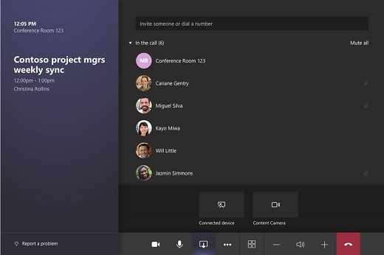

**Stop sharing your desktop**

Select **Stop presenting**on the console.

## **[Make a phone call](javascript:)**

1. Select **Dial pad** Dial pad button on the room console.
2. Dial a number, and then select **Call**.

## **[Manage a meeting](javascript:)**



**Add a participant**

1. Go to **Add participants** Add people to team button and find the people you want to invite.
2. Select people to add them to the list of invitees.
3. After all the people you want to invite are on the list, select **Invite**.

**Pin a participant's video**

When there are multiple people sharing video in a meeting and you want to see one person’s video on your room display, select their name on the room console, then **Pin**.

**Note:** This will only pin the video for the room, not for others in the meeting.

**Remove a participant from the meeting**

To remove someone from a meeting, select their name on the room console, then **Remove participant**.

**Participate in the meeting chat**

1. Select **Conversation**on the room console.
2. Go to **Type a message**, use the keyboard to type a message, and then tap **Send** or press the **Enter**key.

**Note:** For now, this is only available on Skype for Business.

**Manage the screen layout**

1. Select **Layout** on the room console.
2. There, you can toggle between different layouts for your room display.

**Note:** If you have a single display, you can choose between showing just shared content or showing content and a row of people. If you have two displays, one will show content and the other will show people. Selecting **Layout**will swap which display shows which.

**Manage audio**

* Select **Mic** Mute button  on the room console to mute or unmute the room mic.
* Select **Volume up** or **Volume down** to adjust the speaker volume or mute the speaker.
* Mute participants by going to **Participants**, selecting a name, and then **Mute participant**.

**Manage video**

1. Select **Camera** Video call button on the room console to turn the room camera on and off.
2. Choose which video device you want to use, or tap **Camera Off** to stop streaming the room's video.

**Note:** For now, you can only switch between cameras on Skype for Business.

**Remove uploaded content**

If you leave the meeting room before your scheduled meeting time has ended, you can remove any content that you uploaded for the presentation.

1. Go to **Content** on the room console and select the content that you want to remove.
2. Select **Remove**.

**Leave a meeting**

Select **Leave meeting** on the room console to leave a meeting.

Then, rate the call on the room console using a scale of 1 - 5 stars.